K.MARIMUTHU

1911030

1.Create a Bucket in IBM object storage.

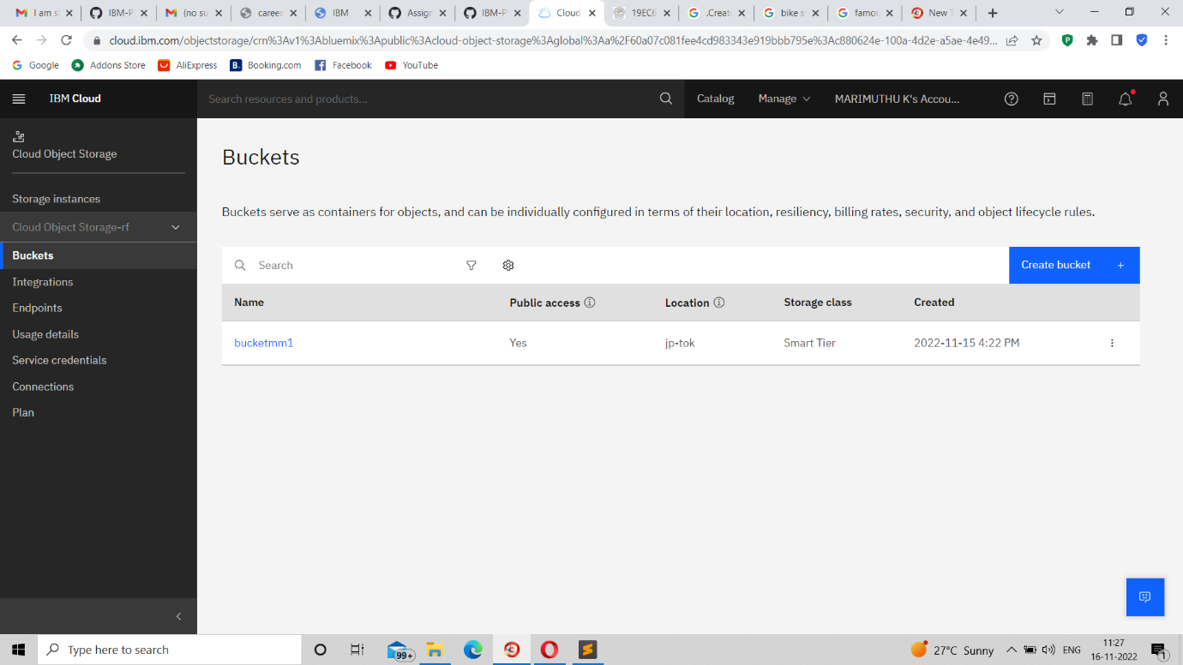

2.Upload an 5 images to ibm object storage and make it public. write html code to displaying all the 5 images.

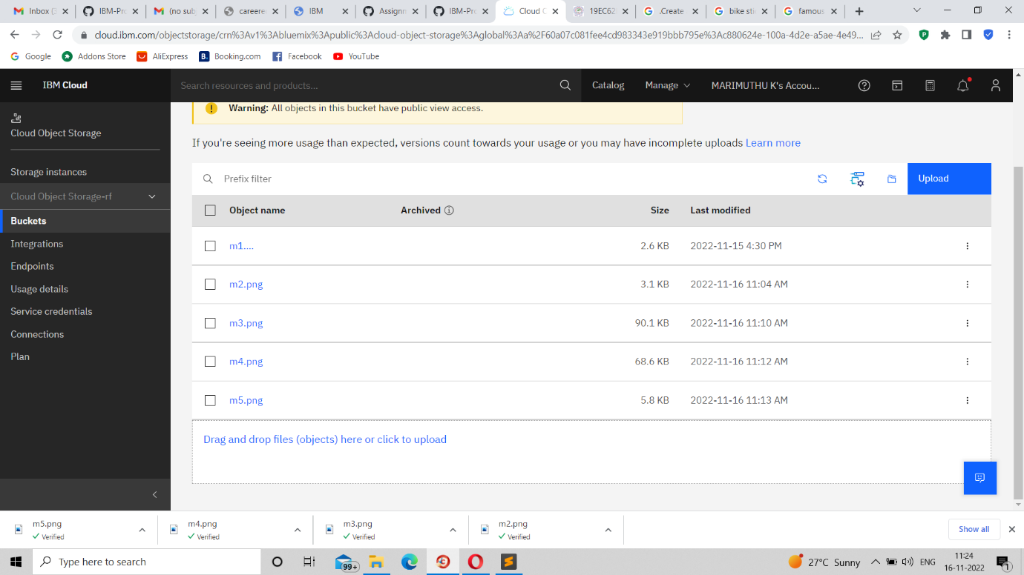

4.Design a chatbot using IBM Watson assistant for hospital. Ex: User comes with query to know the branches for that hospital in your city. Submit the web URL of that chat bot as a assignment

<https://web-chat.global.assistant.watson.appdomain.cloud/preview.html?backgroundImageURL=https%3A%2F%2Fau-syd.assistant.watson.cloud.ibm.com%2Fpublic%2Fimages%2Fupx-efee311d-af09-4005-a81d-416c56abdb91%3A%3A341e0cb7-45be-47bd-bff6-4725851a86b2&integrationID=16ed700f-93d6-45ae-8bc8-1d23729ee955&region=au-syd&serviceInstanceID=efee311d-af09-4005-a81d-416c56abdb91>